**East West University**

**CSE412: Software Engineering**

**Project Report (Software Design)**

**PET : Personal Expense Tracker**

**Section: 2**

**Group: 08**

**Group Name: Team Noob**

**Name & ID of Students:**

| Abu Kahhar Mohammad Sakib | 2021-1-60-040 |
| --- | --- |
| Prioti Kar Tithy | 2022-1-60-082 |
| Budrun Nahar Bristy | 2022-1-60-144 |
| Fatema Tuz Zannat | 2022-1-60-153 |

**Course Instructor Information:**

Yasin Sazid

Lecturer

Department of Computer Science and Engineering

East West University

**1. Introduction:**

**Project Overview:**

## The Personal Expense Tracker is a software application that enables users to manage their daily financial transactions efficiently. Through this tracker user can track the budget via a web-based application. For starters, he sets up an account via his email and password. Upon sign-up, he securely logs in to access his saved financial data on the website. With the dashboard, he can create new spending and income transactions by inputting fields like description, date, category, and amount. If they make a mistake, they can revise or remove transactions to maintain their records accurately.

To better control expenses, the user allocates transactions to predefined categories like Food, Rent, and Entertainment. They can define monthly budget limits for certain categories or all together to limit spending and get notified when they are near or have crossed their budget. The system also offers AI-driven forecasts for next month's spending based on historical spending patterns, enabling them to plan their finances.

The user can also invite family members to the platform, making it a family-shared expense tracker. Every member can monitor their income and expenses, which will create a combined financial summary. The system will update all transactions in real-time, so everyone will be made aware of the economic condition of the family. To check their spending, users visit the reports feature, where they get interactive graphs and charts displaying money trends. Users can filter reports based on date, category, or transaction type to receive precise information. The system should further provide a breakdown of total income, spending, and savings over a specified time and give a general financial overview for the user or the entire family.

**List of Requirements :**

**Functional Requirements (FRs):**

* A user should register/ sign up with proper authentication to enter the website
* Users should be able to add, edit, and delete expenses
* Users should be able to add, edit, and delete income sources
* Categorization of expenses (Food, Transport, Rent, Shopping) should be maintained by the website
* Users can set monthly budget and track expenses
* Uses can get visual representation of financial data (Graphs, Charts)
* Report generation (Daily, Weekly, Monthly summaries) should be viewed by the website
* The users should get alert messages for nearing the set budget or exceeding it.

**Non-Functional Requirements (NFRs):**

* User data should be protected and to login the user should need proper authentications.
* Application should load within 5 seconds.
* The interface should be simple and mobile-responsive.
* The system should support multiple users simultaneously.

**Extra-Ordinary Requirements (Wow Factors):**

* Provide smart recommendations based on spending habits using AI.
* Enable seamless synchronization of data across multiple devices.
* The website should support shared budgeting for families and groups.
* The website might reward users with badges for achieving savings goals.

**Technology Stack:**

| **Area** | **Technology** |
| --- | --- |
| Frontend | React.js |
| Database | Firebase Firestore |
| Authentication | Firebase Authentication |
| Hosting | Firebase Hosting |
| Version Control | Git + GitHub |
| Build Tool | React Script |
| Styling | CSs |

**2. Architectural Design:**

**Data-Centered Architectures:**

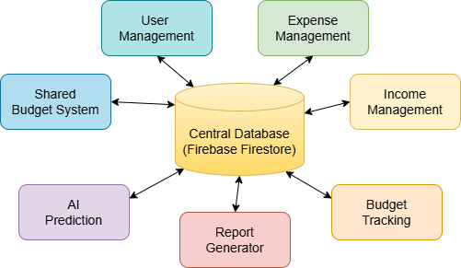

**Architectural Context Diagram: Level 0**

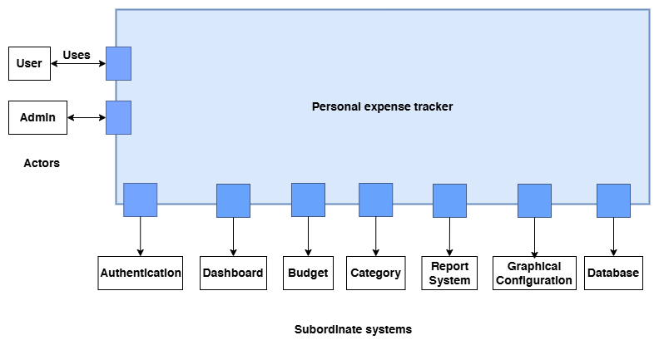

**Architectural Context Diagram: Level 1**

**Authentication :**

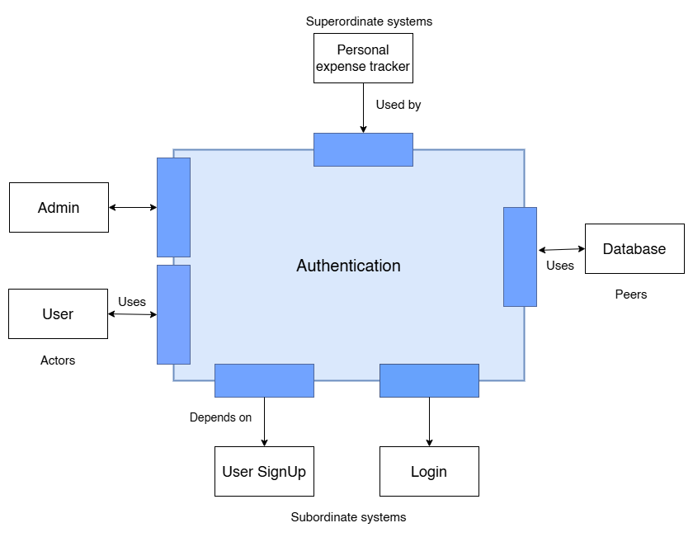

**Dashboard :**

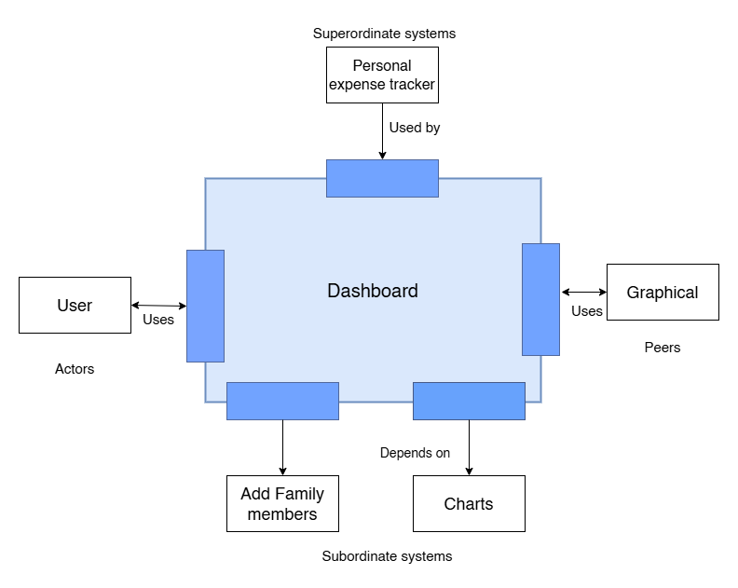

**Budget :**

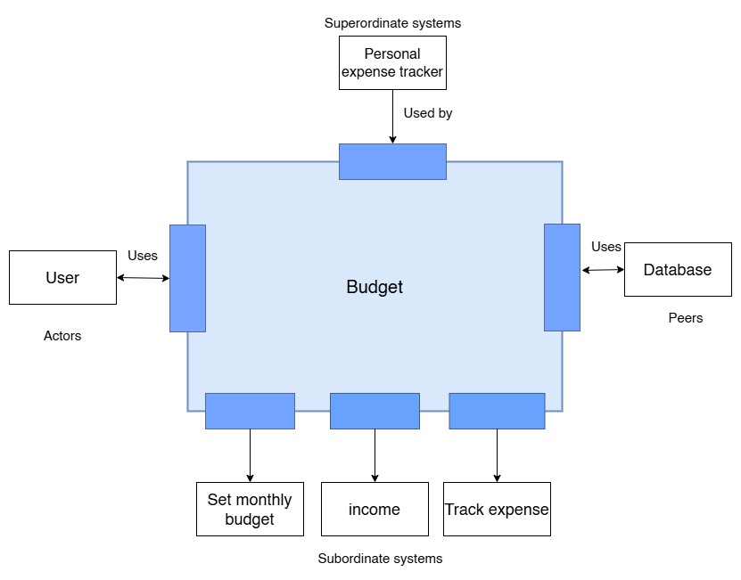

**Category :**

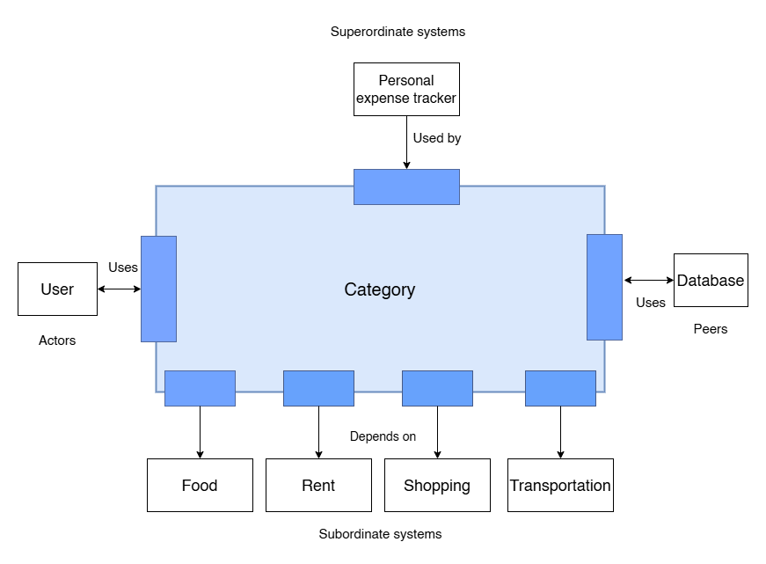

**Report System:**

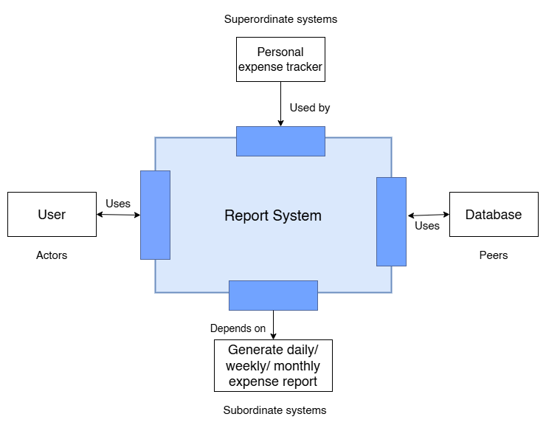

**Graphical Configuration :**

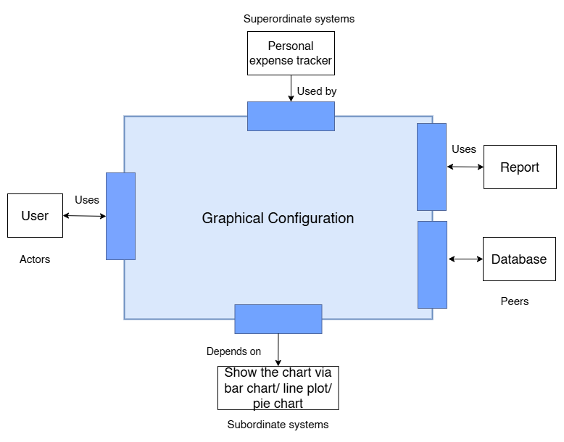

**Database :**

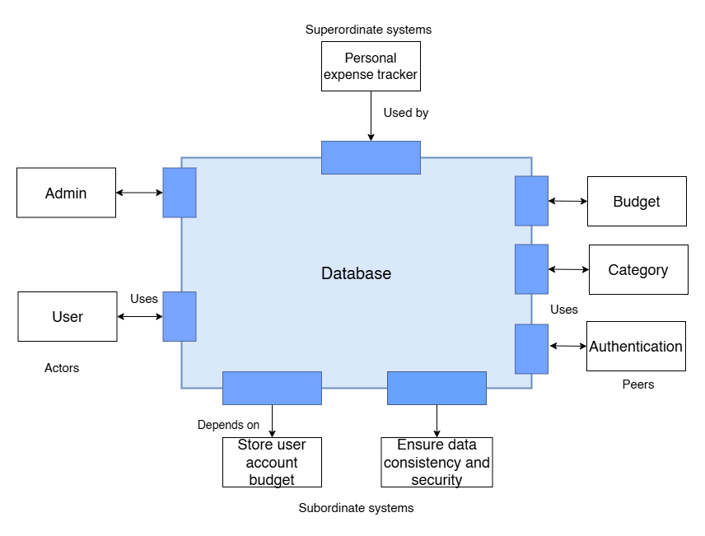

**Top-Level Component Diagram:**

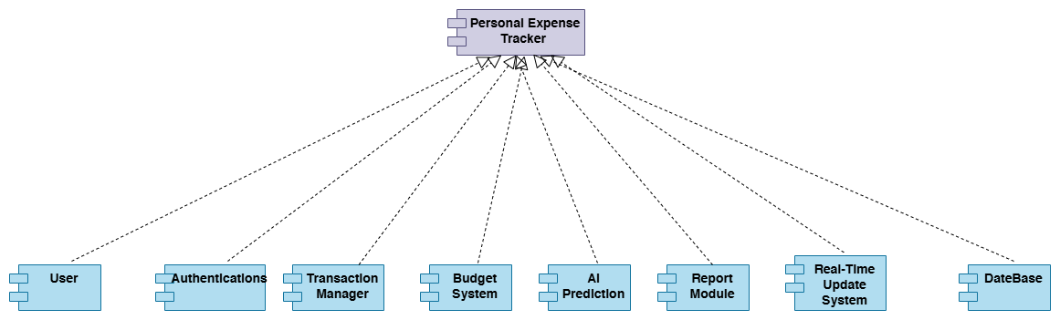

**Instantiation of Each Component with Component Elaboration:**

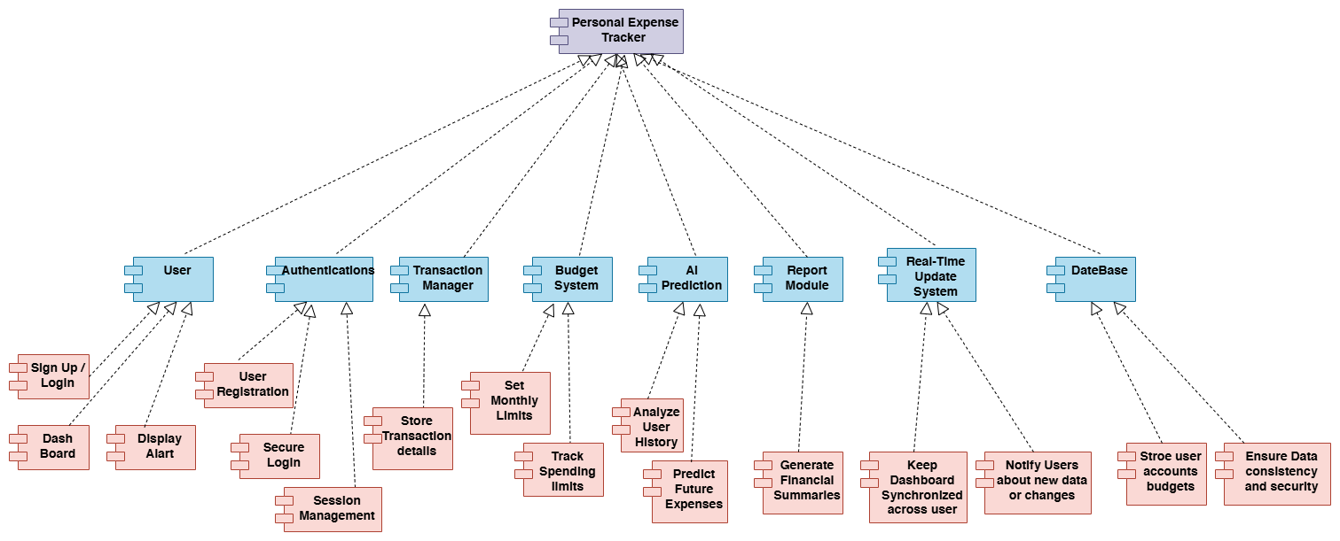

**3. Component-Level Design :**

**For User :**

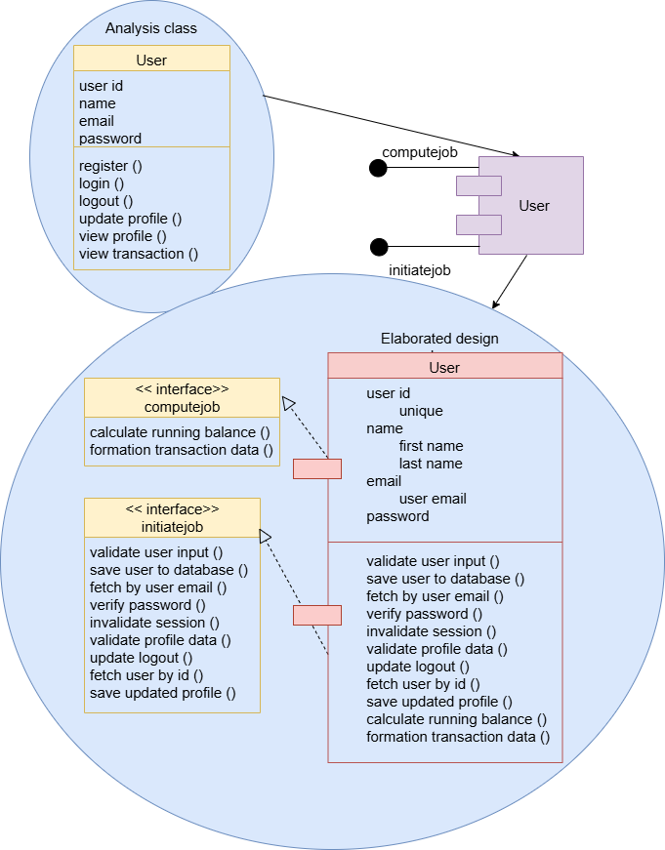

**For Family :**

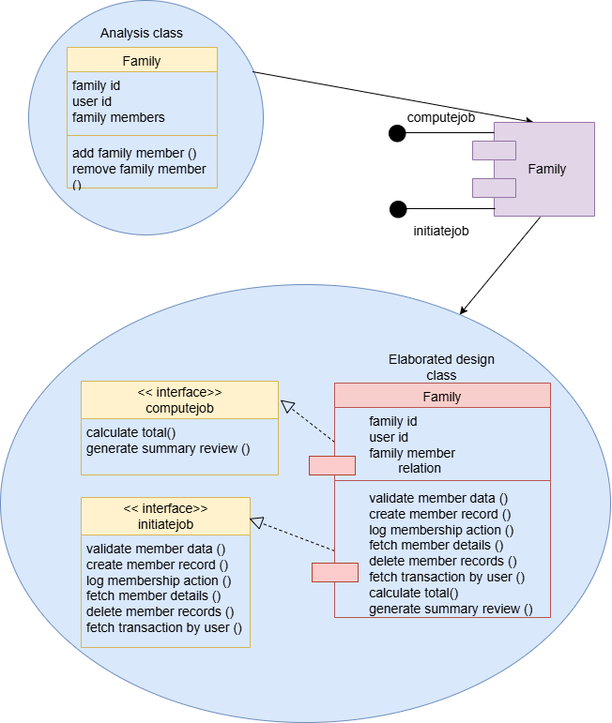

**For Report :**

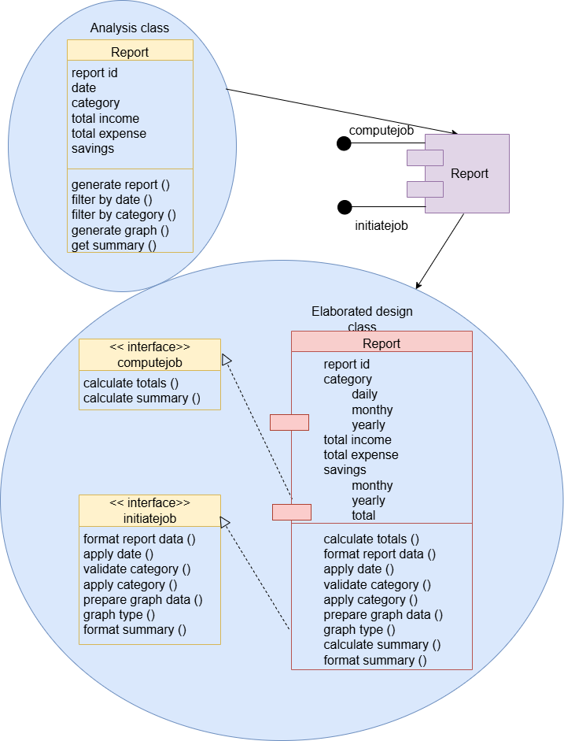

**For Transaction :**

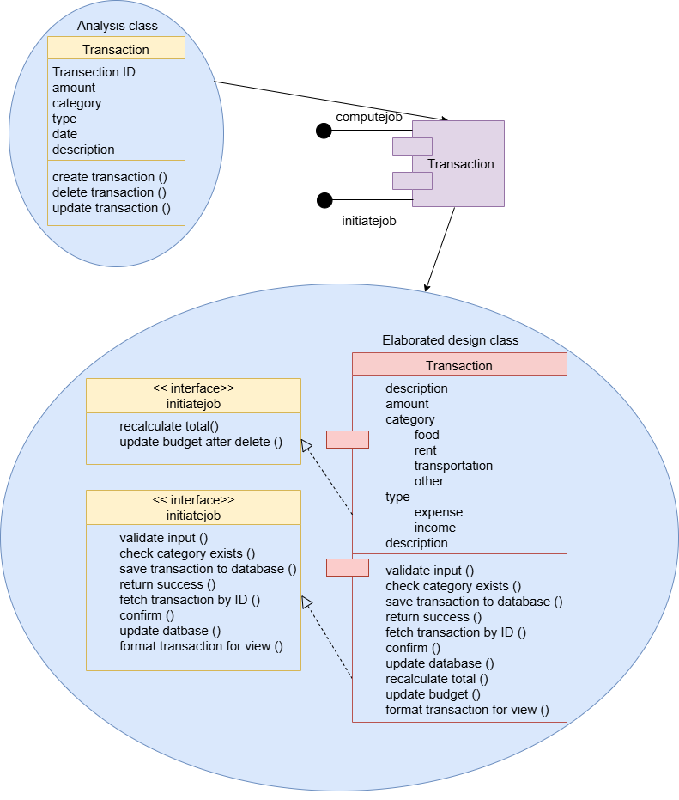

**For Budget :**

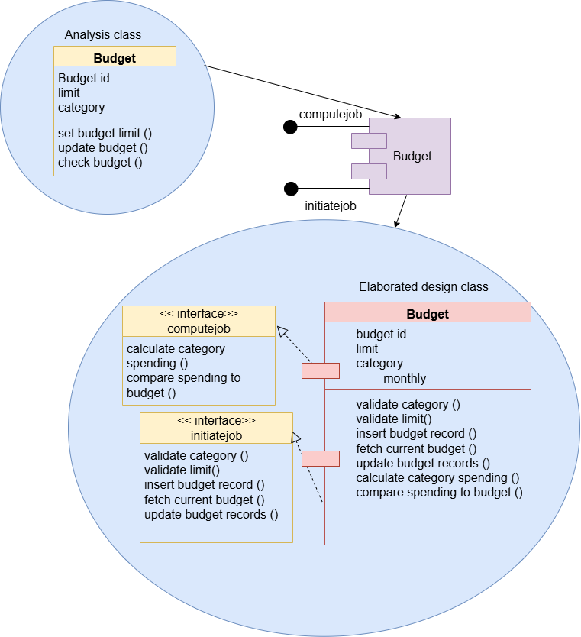

**For Prediction :**

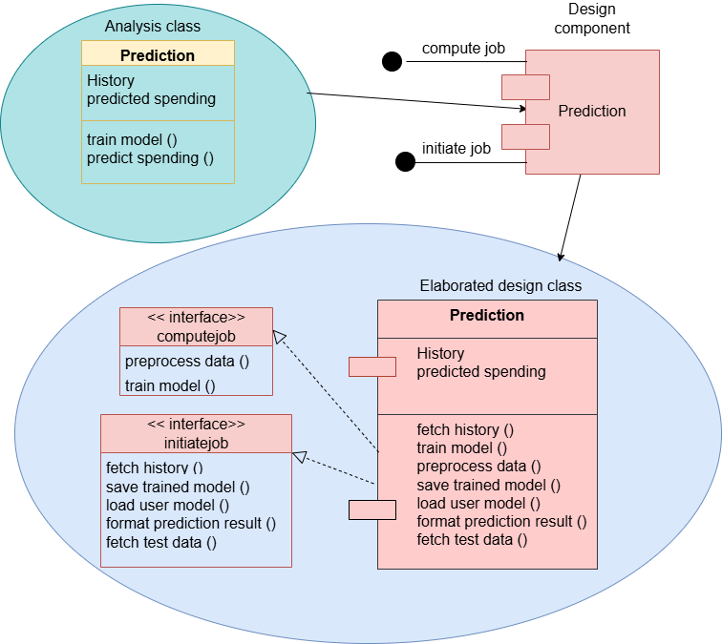

**Class Diagram**

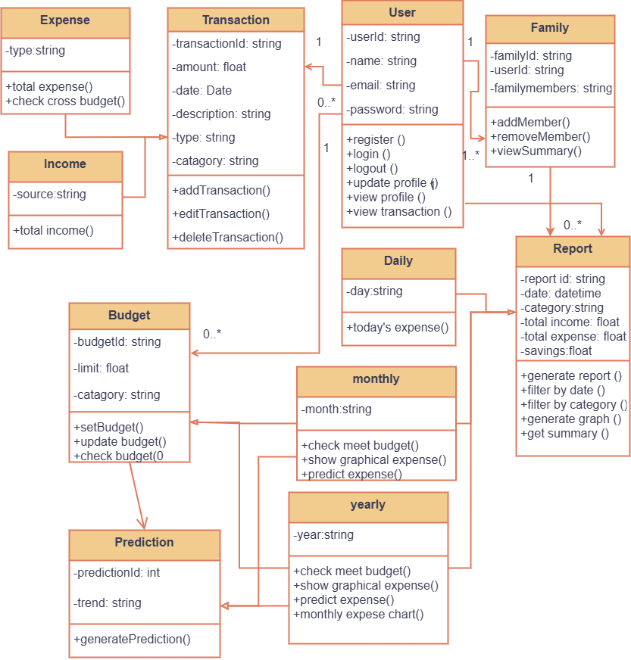

**ER Diagram**

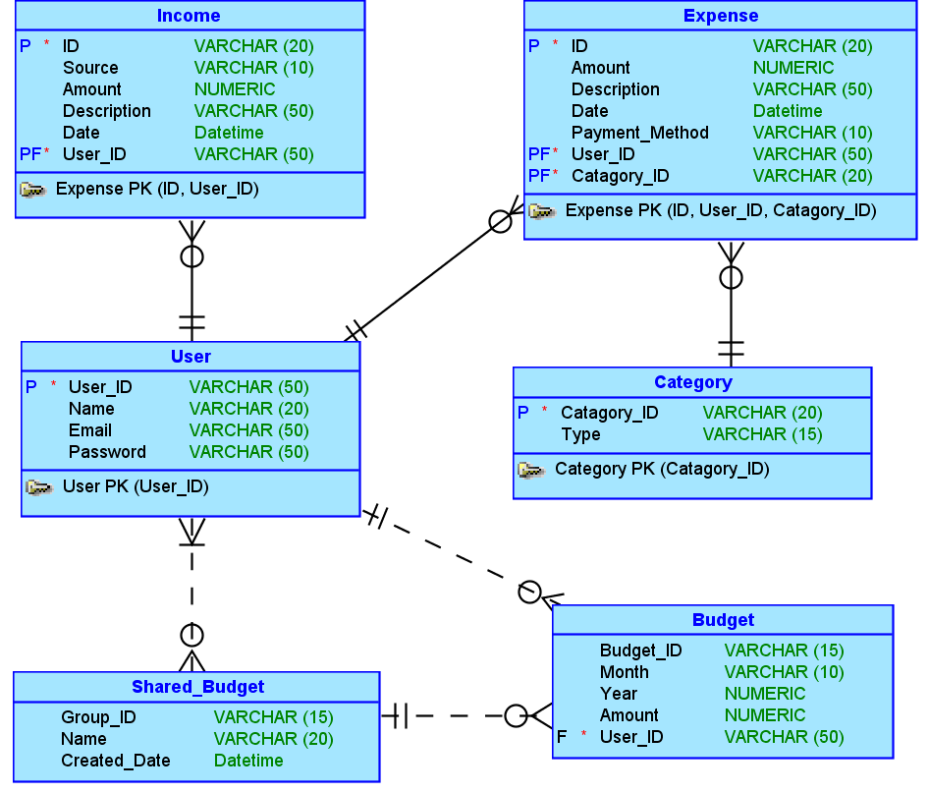

**4. User Interface Design**

